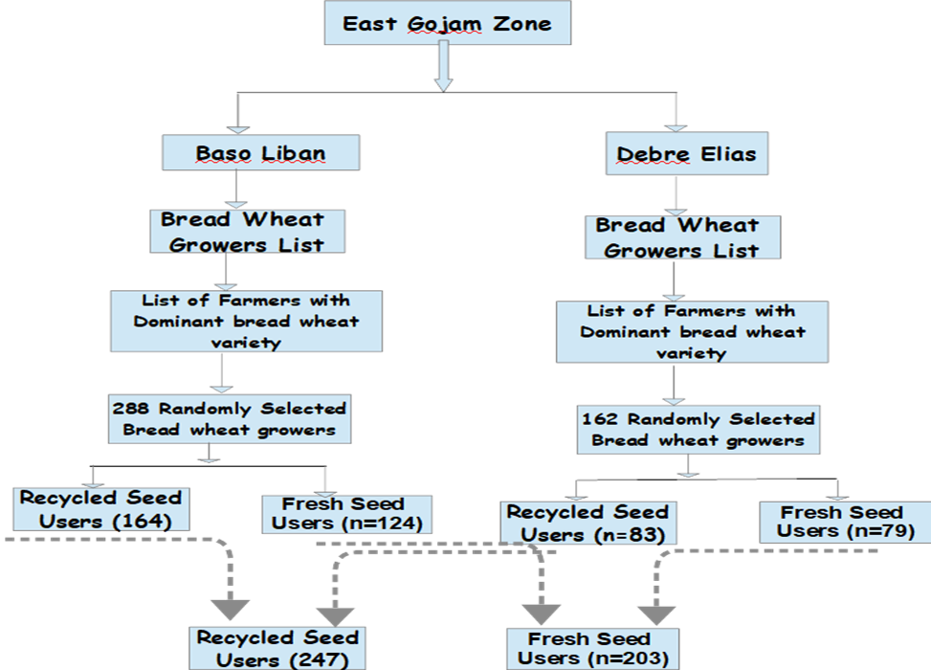

Figure 2: Sampling Procedure